The following explains why and when a ball is ruled fair or foul.
Play No. 1: The ball hits in foul territory at Point A, hits a pebble and bounces into fair territory at Point B, and is fielded or comes to rest there. FAIR BALL | 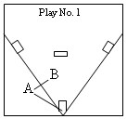
Play No. 2: The ball hits at Point A in fair territory but spins into foul territory and comes to rest, or is touched, at Point B.  FOUL BALL | 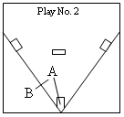
Play No. 3: The ball hits at Point A in foul territory, spins forward and comes to rest directly on home plate.  FAIR BALL | 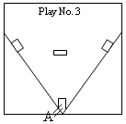
Play No. 4: The ball hits the batter's leg while he is in the batter's box, bounces into fair territory and is fielded there.  FOUL BALL | 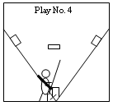
Play No. 5: There is a runner taking his lead off third base in foul territory. A line drive hits him and then bounces fair, where it is fielded.  FOUL BALL | 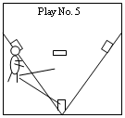
Play No. 6: A line drive hits the pitchers rubber without touching a player and caroms into foul territory between home and third and bounces into the seats. FOUL BALL | 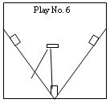
Play No. 7: Ball rolls directly along the foul line. Touches a corner of the base and then rolls fouls never passing the bag.  FAIR BALL | 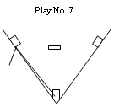
Play No. 8: Ball bounces in front of the base at Point A, crosses directly over the bag and lands in foul territory beyond the bag.  FAIR BALL | 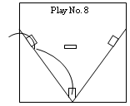
Play No. 9: Line drive zooms over third base in fair territory but lands on the foul side of the left field line.  FOUL BALL | 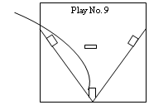
Play No. 10: Ball hits fair at Point A, spins foul, hits a pebble at Point B, comes back into the diamond, crossing directly over the bag and comes to rest at Point C.  FAIR BALL | 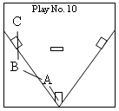
Play No. 11: Ball rolls inside the line, then at Point A dips into foul territory before reaching the bag, but after it passes behind the bag it hits a pebble at Point B and goes fair again, settling at Point C.  FOUL BALL | 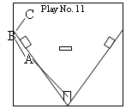
Play No. 12: Third baseman, standing in fair territory, reaches out into foul territory and touches a line drive which is definitely on the foul side of the line. FOUL BALL | 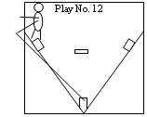
Play No. 13: Left fielder goes into foul territory for a long fly. At the last second the wind carries it into fair territory. While standing in foul territory, he reaches into fair territory to touch the ball.  FAIR BALL | 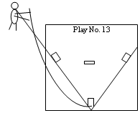

Here's the definition of a fair ball: One that "settles on fair ground between home and first base or between home and third base, OR that is on or over fair territory when bounding to the outfield past first base or third base, OR that touches first or third base, OR that first falls on fair territory on or beyond first base or third base, OR that, while on or over fair territory, touches the person of an umpire or player."
NOTE: A "fly ball shall be judged according to the position of the ball and not whether the fielder is in fair or foul territory at the time he touches it."
Conversely, a FOUL ball is one "that settles on foul territory between home and first base, or between home and third base, OR that bounds past first, or third base on or over foul territory, OR that first falls on foul territory beyond first or third base, OR that, while on or over foul territory, touches the person of the umpire, or a player or any object foreign to the natural ground."
A key word in the above definitions is "settles". Thus, on all calls between the plate and the base it makes no difference where the ball first hits. It must be judged on where it finally comes to rest or is first touched.
Also remember these two things: A pebble is part of the natural ground, just as is the grass. Also, home plate is in FAIR territory.

